Thermochemistry II
ChemieLearn

Imanuel Rava

Defining Entropy
Thermodynamics Framework
Clausius introduced the original thermodynamic definition of entropy, emphasizing its dependence on the state of a system. He established that the entropy difference between two states can be calculated by connecting them through any suitable pathway. If a reversible path connecting the initial and final states is discovered, the entropy change can be determined exclusively by the heat absorbed during the process.
$$ΔS_{sys}=\int_{rev}{\frac{dQ_{in}}{T}}$$
This definition of entropy change called Clausius entropy. The statement suggests that the process of heating or cooling a system leads to the generation or removal of entropy. In the event that the overall Clausius entropy change is negative, it indicates the possibility of constructing a system whose primary function is to efficiently convert heat energy into useful work.
Statistical Mechanics Framework
Within the framework of statistical mechanics, another definition of entropy can be observed, known as Boltzmann entropy. This concept of entropy is derived from the contributions of physicist Ludwig Boltzmann. In statistical mechanics, entropy is closely linked to the number of microstates that correspond to a specific macrostate of a system.
$$S=k_{B}\ln{Ω}$$
where $Ω$ is the number of microstates compatible with some macroscopic parameters. It is crucial to emphasize that when calculating Boltzmann entropy, there is no subjective or arbitrary selection of states, nor any manipulation of their weights. All states that satisfy the macroscopic parameters are considered equally and given equal importance in the determination of entropy. This ensures a fair and unbiased assessment of the system's microstates and their contribution to entropy. The concept of defining entropy (S) based on microstates is advantageous as it permits us to compute entropy by considering the microscopic characteristics of a system. This approach proves particularly useful when dealing with a monatomic ideal gas, as the Boltzmann entropy equation allows us to directly determine the gas's entropy by considering the microstates available to its individual particles.
$$S=Nk_{B}\left[\ln{V}+\frac{3}{2}\ln\left(\frac{mE}{N}\right)+C\right]$$
Another approach to determine entropy involves considering the combinatorial aspect of dividing $N$ particles into $m$ groups, where each group has a specific size ($n_{i}$).
$$Ω=\frac{N!}{\prod_{i=1}^{m}{n_{i}!}}$$
Expanding for large $n_{i}$ provide us with the entropy expression below,
$$S=-k_{B}N\sum_{i}{f_{i}\ln{f_{i}}}$$
where $f_{i}={n_{i}}/N$. The physical meaning of $f_{i}$ can be described as the probabilities of nding a particle picked at random in the group labeled $i$. The entropy that is represented using probabilities and adjusted by the Boltzmann constant, excluding the factor of $N$, is known as the Gibbs entropy.
$$S=-k_{B}\sum_{i}{P_{i}\ln{P_{i}}}$$
Entropy as State Function
To prove that entropy is a state function, it is sufficient to show that the integral of entropy over any closed cycle is equal to zero. This condition guarantees that the entropy value at the initial and final states of the system remains the same, irrespective of the particular route chosen to connect those states.
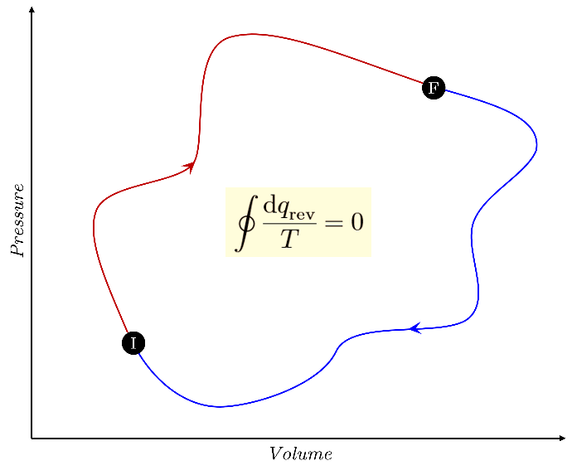
Figure 1: The net change in a state function during a thermodynamic cycle, encompassing the transition from the initial state to the final state and returning back to the initial state, is zero.
Carnot Cycle
The Carnot cycle is a theoretical thermodynamic cycle that serves as an idealized model for the operation of a heat engine. It consists of four reversible processes: two isothermal processes, where the temperature remains constant, and two adiabatic processes, where there is no heat transfer. Note that it is possible to represent any reversible cycle as an approximation using a collection of Carnot cycles.
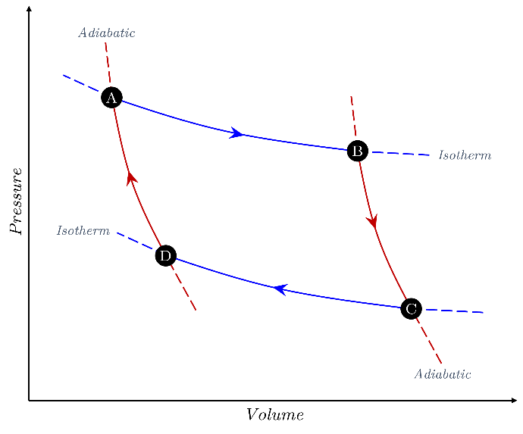
Formally, the Carnot cycle involves the following steps:
During the isothermal expansion process, the working substance absorbs heat from a high-temperature reservoir as it undergoes expansion and performs work. This expansion occurs at a constant temperature, meaning the temperatures at points A and B are equal ($T_{A}=T_{B}$). The associated change in entropy ($ΔS_{A→B}$) can be calculated using the equation,
$$ΔS_{A→B}=\frac{q_{in}}{T_{A}}$$
Where $q_{in}$ represents the heat absorbed and $T_{A}$ is the temperature at point A.
In contrast, during adiabatic expansion, the working substance continues to expand without any heat exchange with the surroundings. This results in a decrease in temperature (from $T_{A}$ to $T_{C}$) and pressure. As there is no heat exchange, the entropy change ($ΔS_{B→C}$) for this process is zero.
Upon reaching the isothermal compression phase, the working substance comes into contact with a low-temperature reservoir, releasing heat as it is compressed and performs work. Similar to isothermal expansion, this compression occurs at a constant temperature. However, the entropy change ($ΔS_{C→D}$) in this case is determined by the equation,
$$ΔS_{C→D}=\frac{q_{out}}{T_{C}}$$
where $q_{out}$ represents the heat released and $T_{C}$ is the temperature at point C.
Finally, during adiabatic compression, the working substance continues to be compressed without any heat transfer. This leads to an increase in temperature and pressure. Since there is no heat transfer involved, the entropy change ($ΔS_{D→A}$) for this process is zero.
Hence, the total entropy of the Carnot cycle can be summed as follows:
$$ΔS_{tot}=ΔS_{A→B}+ΔS_{B→C}+ΔS_{C→D}+ΔS_{D→A} \\ =\frac{q_{in}}{T_{A}}+\frac{q_{out}}{T_{C}}$$
For isothermal process, the heat involved in the process expressed in the following equation,
$$q=nRT\ln\left(\frac{V_{f}}{V_{i}}\right)$$
Now in the isothermal expansion and compression, the expression of $q_{in}$ and $q_{out}$ is given as follows:
$$q_{in}=nRT_{A}\ln\left(\frac{V_{B}}{V_{A}}\right) \\ q_{out}=nRT_{C}\ln\left(\frac{V_{D}}{V_{C}}\right)$$
For a reversible adiabatic process the temperature and volume are related by $V_{i}T_{i}^{γ}=V_{f}T_{f}^{γ}$. Thus for the relation of volume and temperature during adiabatic expansion and compression is given by,
- Adiabatic Expansion
$$V_{B}T_{B}^{γ}=V_{C}T_{C}^{γ}$$
- Adiabatic Compression
$$V_{D}T_{D}^{γ}=V_{A}T_{A}^{γ}$$
Recall that process of $A→B$ and $C→D$ is an isothermal process, thus $T_{A}=T_{B}$ and $T_{C}=T_{D}$, hence the expression for adiabatic expansion and compression can be rearranged into,
- Adiabatic Expansion
$$V_{B}T_{A}^{γ}=V_{C}T_{C}^{γ}→{\left(\frac{T_{A}}{T_{C}}\right)}^{γ}=\frac{V_{C}}{V_{B}}$$
- Adiabatic Compression
$$V_{D}T_{C}^{γ}=V_{A}T_{A}^{γ}→{\left(\frac{T_{A}}{T_{C}}\right)}^{γ}=\frac{V_{D}}{V_{A}}$$
Notice that,
$$\frac{V_{D}}{V_{A}}=\frac{V_{C}}{V_{B}}→\frac{V_{D}}{V_{C}}=\frac{V_{A}}{V_{B}}$$
Hence, one can write the expression of $q_{in}$ and $q_{out}$ based on $V_{A}$ and $V_{B}$ variables,
$$q_{in}=nRT_{A}\ln\left(\frac{V_{B}}{V_{A}}\right) \\ q_{out}=nRT_{C}\ln\left(\frac{V_{A}}{V_{B}}\right)$$
Substituting this to the expression of $ΔS_{tot}$ would yield zero.
$$ΔS_{tot}=\frac{1}{T_{A}}⋅nRT_{A}\ln\left(\frac{V_{B}}{V_{A}}\right)+\frac{1}{T_{C}}⋅nRT_{C}\ln\left(\frac{V_{A}}{V_{B}}\right) \\ =nR\ln\left(\frac{V_{B}}{V_{A}}\right)+\left[-nR\ln\left(\frac{V_{B}}{V_{A}}\right)\right] \\ =0$$

